EXPERIMENT-11
Random Sampling and Sampling Distribution
Aim:
To explore random sampling from population and understand the concept of sampling distribution

Procedure:
1. Create a population of data with specified distribution
2. Perform random sampling from population to create multiple sample of different sizes
3. Compute sample statistics
4. Plot histograms or density plots of each statistics
5. Compare the sampling distribution of the sample statistic of the sample statistic with mean distribution

Program:
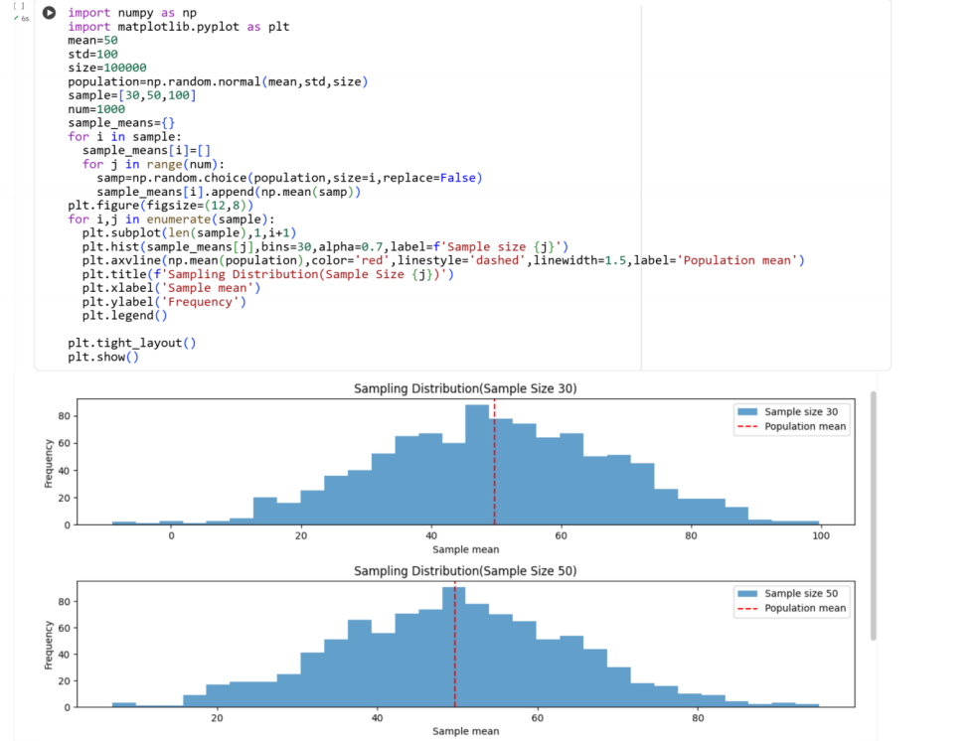
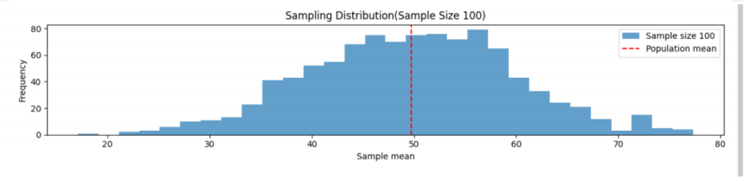
Result:
Thus the python program for random sampling and sampling distribution is executed
and output is verified successfully

